PINEPHONE USER MANUAL - QUICK START GUIDE

1 Packaging contents 2
2 Safety cautions and recycling 2
2.1 Cautions 2
2.2 Recycling of components and batteries 2
3 Getting started 3
3.1 Back case removal 3
3.2 Initial setup 3
3.2 Privacy switches and pogo pins 3
3.3 Operating the PinePhone 4
4 Operating systems 4
5 Hardware 4
5.1 External component description 4
5.2 Device hardware specifications 5
5.3 Troubleshooting common issues 5
6 Regulatory compliance 5
7 Documentation and contact information 5

1 Packaging contents
- User Manual - Quick Start Guide (x1)
- PinePhone (x1)
- USB-C power cable (x1)

2 Safety cautions and recycling

2.1 Cautions
Before using the device please read this manual carefully.
Operational variables and cautions:
- The PinePhone should be charged using a 15W (5V 3A) USB-PD power adapter. Charging at a higher voltage may result in damage to the device.
- The PinePhone will only operate when its internal temperature is between 5*C and 65*C. It should never be operated with an external temperature lower than -20*C or higher than 40*C.
- Do not puncture, disassemble, strike or squeeze the battery. Old batteries need to be disposed of in accordance with local regulations (see section 2.2).
- Do not expose the device to direct sunlight, water or high density moisture.
- In the event of overheating, power off the PinePhone and let it cool for 15 minutes.
- Comply with local regulation pertaining to using mobile devices. This extends to and includes use of the device in public spaces, when operating motor vehicles and heavy machinery.

2.2 Recycling of components and batteries
Recycling any PinePhone components should be done according to local regulation. This may require you to dispose of the phone or its parts at a local recycling centre or at a designated container.
Please consult local legislation for details.
Batteries should never, under any circumstances, be disposed of with general household waste.
The end user is legally obliged to return used batteries. Batteries can be returned to us to be disposed of. The batteries are to be returned to the sender - for more information contact us on info@pine64.org.

3 Getting started

3.1 Back case removal
To remove the back case of the PinePhone, use your fingernail or another soft object to pop up the back case. A notch to easily remove the cover is located at the bottom left of the PinePhone when its back is facing you and its camera is oriented up.

3.2 Initial setup
Your PinePhone arrives with a plastic strip placed between the power connectors and battery. You need to remove it prior to use.
- remove battery using your fingernail or a prying tool
- remove and dispose of the plastic strip placed between the battery and power connectors

You may insert a SIM card and microSD card into the phone with the back case and battery removed. A microSD card may be used to provide an operating system to the PinePhone, or it may serve as additional storage for an operating system installed internally to eMMC. Do not attempt to remove the microSD or SIM cards with the battery inserted into the device.

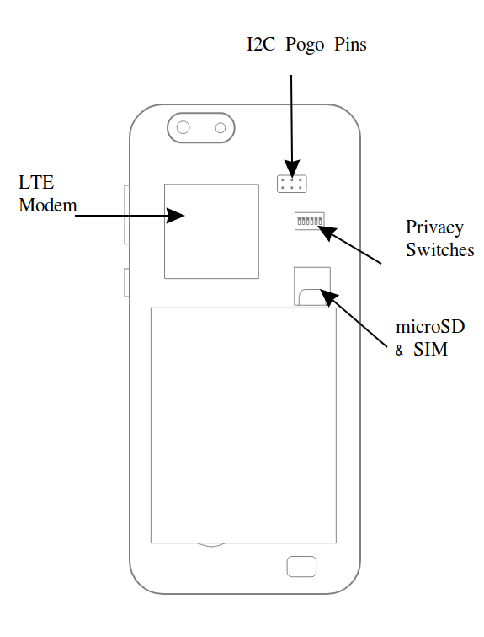

3.2 Privacy switches and pogo pins
Under the cover you find pogo pins and privacy switches labeled 1-6 with their respective functions. Pogo pins use the I2C (two pins) protocol and can be used for accessories and additional functionality.

Privacy switches can be engaged to electrically disable (numbers according to legend on device):
- LTE modem + GPS
- WiFi / Bluetooth
- Microphone
- Read Camera
- Front camera
- Headphones OFF / UART ON switch

Disabling headphones enables UART output via the headphones jack (see Wiki for details).

3.3 Operating the PinePhone
The PinePhone is capable of running multiple operating systems (OSes) (see section 4) from internal flash eMMC as well as a SD card. Bootable SD cards have priority over internal eMMC.

To power the PinePhone ON, press and hold the power button for 2 seconds. Boot-up time varies from one OS to another, but you should permit up-to 60 seconds for the phone to start fully. Most OSes have a boot indicator such as a vibration rumble or notification LED flash.

For detailed instructions and to select and operating systems please please visit: https://wiki.pine64.org/index.php/PinePhone

4 Operating systems
All OSes available for the PinePhone are delivered by community developers and partner-projects. PINE64 does not create software for the PinePhone.

Regardless of which OS comes pre-installed on your device, you can install and run any other OS available for the PinePhone. Please reference our Software Release section on Wiki for more details: https://wiki.pine64.org/index.php/PinePhone_Software_Release#Software_Releases

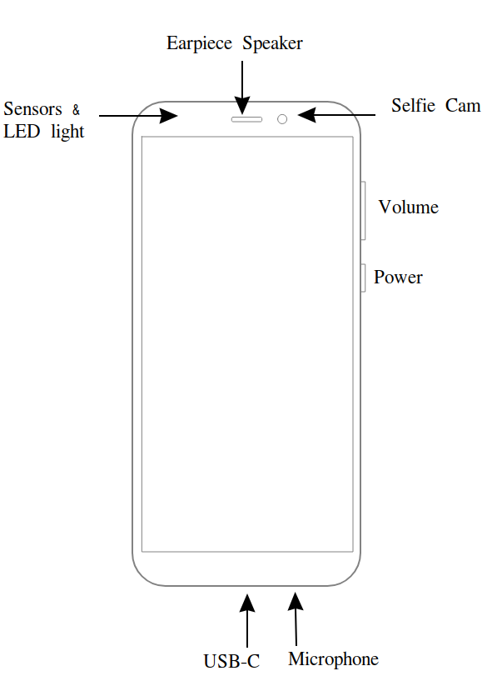
5 Hardware

5.1 External component description
Device dimensions: 160.5 x 76.6 x 9.2mm. Device weight: 220 grams.
The PinePhone features a 5.95” HD IPS capacitive touchscreen (16M colors; 1440x720, 18:9 ratio). The headphone jack is located on the top leading edge. The top bar above the LCD houses a 2MP, f/2.8, 1/5" front-facing camera, a multi-color notification LED, a proximity sensor, an ambient light sensor as well as the earpiece speaker. Power button and the volume rocker are located at the right leading edge.
The bottom leading edge houses the USB type C port (power, data and video out in DisplayPort Alternate mode) and microphone. On the back of the device, in the left top corner, a 5MP, 1/4" camera and LED flash are to be found. A mono loudspeaker is found at the bottom of the device.

5.2 Device hardware specifications
More information, including PCBA hardware revisions and schematics at: https://wiki.pine64.org/index.php/PinePhone

Key hardware specifications:
- System on Chip: Allwinner A64
- RAM: 2GB LPDDR3 SDRAM
- Storage: 16GB eMMC, extendable up to 2TB via microSD, supports SDHC and SDXC, UHS1
- Communications modem: Quectel EG25-G
  - LTE: B1, B2, B3, B4, B5, B7, B8, B12, B13, B18, B19, B20, B25, B26, B28, B38, B39, B40, B41
  - WCDMA: B1, B2, B4, B5, B6, B8, B19
  - GSM: 850, 900, 1800, 1900 (MHz)
- WLAN: Wi-Fi 802.11 b/g/n, 1x1, single-band, hotspot capable
- Bluetooth: 4.0, A2DP
- GNSS: GPS/GLONASS/BeiDou/Galileo/QZSS, with A-GPS

5.3 Troubleshooting common issues
- To perform a hard shutdown, hold the power button down for 5 seconds.
- In the event one or more components of the PinePhone fail to engage, ensure that the privacy switches (see section 3.2) are in the ON position.
- The battery must be installed for all components of the PinePhone to function properly.
- With no OS installed battery may discharge over time.
- Not all OSes support all of PinePhone’s hardware features.

6 Regulatory compliance
The PinePhone is CE and FCC certified.

7 Documentation and contact information
Detailed hardware and software documentation can be located on our website (pine64.org) and Wiki (wiki.pine64.org).
Contact
Sale enquires: sales@pine64.org
Support: support@pine64.org
General enquiries: info@pine64.org

